

GRADE 11
MARCH CLASS TEST
HISTORY

40 minutes 40 marks

NAME: ___________________________ KEY:__________
Examiner: Mr. D Edwards
Moderator: Mrs. J Mogg
INSTRUCTIONS:
- This paper consists of 3 pages.
- This paper consists of 12 questions.
- You are to answer all the questions in your test book.
- Make sure your answers are clearly written.
- Time yourself and do not spend too much time on one question and too little on another.

Total - /40 marks
Source 1
“As first general secretary of the NUM Ramaphosa embarked on an exhausting round of union organizing, collective bargaining, and public activities that showed few signs of abating even in the 1990s. Under his skillful direction the NUM grew rapidly, learning from its mistakes and concentrating its organizing efforts on those mines where management was most receptive. Within five years the NUM had a membership of over 300,000 workers, making it the fastest growing union in the world and one of South Africa's largest and most powerful unions. The NUM focused its campaigns on wages and working conditions and on the colour bar that for years had reserved skilled mining jobs for whites only.”

J. Crush, "Migrancy and Militance: The Case of the National Union of Mineworkers of South Africa," in African Affairs (1999)

- What does NUM stand for? (2)

National Union of Mineworkers

- Was Cyril Ramaphosa an effective leader of NUM? Justify your answer using evidence from the source. (2)

Yes, he was described as having “skilled direction”
NUM grew quickly – 300000 members
Fasted growing TU in South Africa

- What did NUM focus its campaign on in the 1980s? (2)

Wages and working conditions
Colour bar

- Was NUM a popular Trade Union? Use 2 good sentence to justify your answer. (4)

Yes
Grew quickly with 300000 members in 5 years, shows it was an organization people wanted to be a part of.
Campaigned for wages, working conditions and the colour bar, there were things all workers wanted making the organization popular as the cause was popular.

- What tactics/approach did NUM use to achieve their aims? Give 3 explained points, using your background knowledge, why these tactics would have been so successful in the mid-1980s. (6)

Collective bargaining – successful because NUM focused on mines that were receptive to change
Public activities – large union so public activities happened on a large scale, major disruption or movement
Stayaways – large union so financial pressure on mine owners and government
Strikes – protected by government as they were registered, so mass participation with no fear of job loss

- Why did Trade Union leaders, in the 1980s, became influential political leaders’ post 1994? Answer using your background knowledge as well as the source. (4)

Trade Union leaders showed powerful leadership abilities.
ANC banned by the NP in the 1960’s.
UDF, COSATU and NUM had strong ties to the ANC leaders.
ANC came into power in 1994 and drew leaders from TU’s as it was known they had good leadership qualities.

Source 2
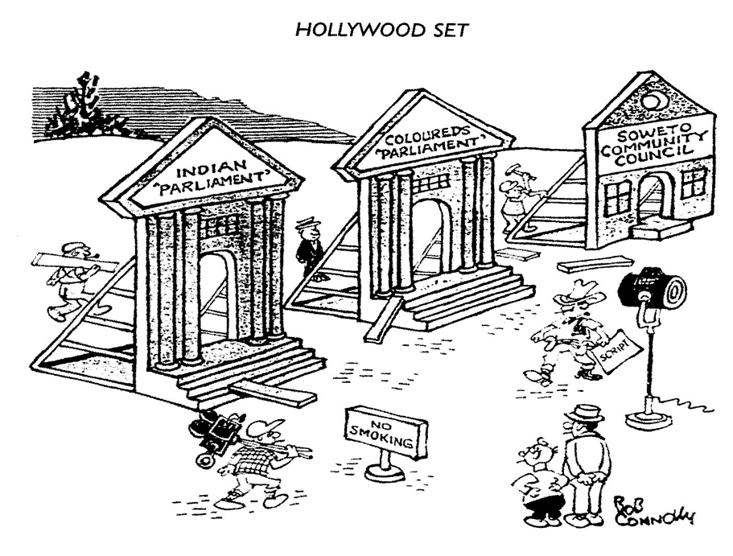

A cartoon by Bob Connolly in the mid-1980s commenting on the political reforms introduced by PW Botha. View Account View Account

Bob Connolly was born in Paterson New Jersey. He briefly studied journalism at Columbia University before embarking on a career as a cartoonist. He moved to South Africa in 1937 just before the outbreak of the Second World War on a one-year contract and stayed there for the rest of his life. Connolly’s work appeared in many South African outlets, but he was best known for his ever-present ‘Little Man’ in his cartoons, represented the average South African in the street, and his daily ‘Breakfast Quip’, which appeared on the front page of the Rand Daily Mail for almost two decades.

- What organization/political structure is being referred to in the source? (2)

Tricameral Parliament

- What evidence in the Source supports the fact that Connolly was raised in the USA? (2)

Born in New Jersey and studied at Columbia University.
Makes reference to Hollywood

- List 3 visual clues that show the cartoonist believes this organization/political structure referred to is a façade (false appearance). (3)

Stands keeping the set design of the Tricameral Parliament up.
Movie cameras
Man holding ‘script’

- What is the message/meaning of the cartoon? Justify your answer with reference to the source. (4)

That Botha’s reforms, especially the tricameral parliament, are not intended to bring about meaningful change in South Africa – this can be seen by the movie set, as if this reform is just an act being put on for the world to watch.
That the tricameral parliament is not real – this can be seen by the actors and movie directors making a fiction movie (as shown by the set design) involving the parliament.
That the tricameral parliament is put on/fake – this can be seen by the quotation makes around the word parliament indicating sarcasm about the authenticity of the parliament.

- What is the value of the source? (3)

Can see how this cartoonist views the tricameral parliament as fake/not real
We can see the structure of the parliament with 1 parliament for Coloured’s and 1 parliament for Indians.
We can see that black people did not have a house, only a community council.
We can learn that movies are made in Hollywood.

- What are the limitations of the source? Provide 3 justified points as your answer. (6)

Bias + explanation
Exaggerated + explanation
Leaves out information + explanation
Satirical + explanation
Subjective/Opinionated + explanation

[40 Marks]

